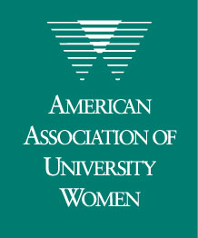
Monmouth, Illinois
October 2007

Celebrating 83 Years of AAUW in Monmouth!

President’s Report
Ronda Willhardt

“Bittersweet October. The mellow, messy, leaf-kicking, perfect pause between the opposing miseries of summer and winter.” — Carol Bishop Hipps

We have yet to have much of a pause in summer warmth but we know it is just a matter of time. I hope you enjoy a wiener roast, have pumpkins on your porch, partake in the delights of a scenic drive, walk along kicking leaves and read a banned book in honor of National Banned Books Week.

Many thanks to presenters, hostesses and attendees for making the September meeting a lively discussion based on educational issues for Hispanic girls and women in our area followed by an enjoyable social time and an effective business meeting.

Our October program will bring the opportunity to view Katie Kahn’s art and gain insight into her work at the Monmouth College art gallery. We are fortunate in our area to have the MC gallery and the Buchanan Center for the Arts to provide us with varied exhibitions, including those of women in the arts. For those willing to travel farther, the current exhibit at the National Museum of Women in the Arts in Washington, D.C., is “WACK! Art and the Feminist Revolution.”

This exhibit, which includes national and international artists, is the first comprehensive exhibit to explore the impact of feminism on art from 1965 to 1980. It is also the largest exhibit in NMWA’s 20-year history, taking two floors and 12,000 gallery feet.

WACK! captures the fundamental shift in women’s perceptions of their social roles during this time frame and the impact the shift had on art. According to Susan Fisher Sterling, NWMA chief curator, “Feminist art is less a movement defined by certain artistic conventions than a philosophy of art informed by gender.”

Some of the art in the exhibit still shocks and outrages its viewers. WACK! is set up thematically instead of chronologically and warnings are posted in areas to alert visitors of potentially disturbing subject matter.

For those interested in learning more about WACK! or the NMWA, visit the museum’s website at www.nmwa.org.



This newsletter is chock-full of news about AAUW national, state and local happenings and issues. Read through it carefully, and then head outside for fresh air and to breathe in fall. I happen to think along the same seasonal lines as George

Inside this issue
Branch Meeting page 2
Upcoming Events page 2
¡Adelante! Book Group page 3
WITASWAN Film Group page 3

Membership News page 3
Meet New Member Kath Sturgeon page 4
Art Presenter Program page 4
Buchanan Center for the Arts page 4
Facts About the Illinois Education Crisis page 5
AAUW-IL State News page 6

Eliot: “Delicious autumn! My very soul is wedded to it, and if I were a bird I would fly about the earth seeking the successive autumns.”

Branch Meeting:
“Sea Change” Exhibition at
Monmouth College
Lila Blum

Our program on Monday, October 15, is a gallery talk in the Len G. Everett Gallery at Monmouth College by Tyler Hennings, Lecturer in Art and Gallery Director, who will discuss the art works of Katie Kahn in her exhibition, “Sea Change.”

Kahn is an Associate Professor of Art at Northern Illinois University who received her MFA at Yale University in 1976 and a BFA from the California College of Arts and Crafts in 1974. She has a distinguished record of exhibitions and awards. In these works, she selects pages from The New York Times as the background support, then uses colored pencil, ballpoint pen, or paint to transform the newspaper images and words into new forms and complex patterns. The finished works, on close examination, appear to channel the daily flow of news into a social commentary on current topics and issues. This show departs from convention in that the series of unframed works are pinned to the wall and together form an installation entitled “Sea Change.” Katie’s work is certain to perk our curiosity and imagination and make us think.

Tyler, who is originally from Industry, IL, holds an MFA degree from Northern Illinois University where he studied under Katie Kahn and a BFA in painting from Western Illinois University. He has taught painting, drawing, methods and materials, and senior art seminar at Monmouth College since 2004 and this semester is teaching a section of the Introduction to Liberal Arts course for freshman students. He has also been an instructor at Carl Sandburg College and at Western Illinois University. This summer he received 2nd place for his oil painting, “20620 (Hydrastatic Afternoon)” at the 57th Biennial Quad-State Juried Exhibition at the Quincy Art Center. His works were also accepted at the 3rd Annual Exhibition at the 33 Collective Gallery in Chicago and at the 22nd Biennial Southern Illinois Artists Open Competition and Exhibition at the Cedarhurst Center for the Arts in Mt. Vernon, Il.

Please join us on the 15th for a special opportunity to view the Kahn show with Tyler and learn more about these interesting works.

Following the gallery talk, we’ll move downstairs to Room 124 for the business meeting. In compliance with the restriction on food from off campus, we will not serve refreshments at this meeting.

A word about parking: Our meeting takes place during the college fall break, so parking should not be a problem. To park in the lot close to the library on the west side, take North 6th Street to Clinton Avenue, turn east toward the campus and proceed the equivalent of two blocks. The parking lot will come into view. Parking is also available along the street on East Detroit Avenue between North 9th Street and North 10th Street. After parking and walking the short distance to 9th Street, walk south and enter the campus between Cleland and Winbigler Residence Halls. The entrance to the east side of the library comes into view.

The “F Word” Series and Other Upcoming Events
Jan De Young

Many of us enjoyed branch member Trudi Peterson’s recent talk in the “F Word” Series last month at Monmouth College. The next three talks in the series have been scheduled as follows:

October 10: Chris Johnston
November 14: Anne Mamary
February 20: Rob Hale

Please email Marlo Belschner at mmb@monm.edu for information regarding time and location.
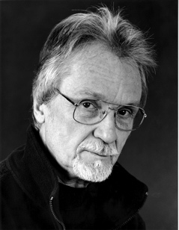
On October 16, at 7 p.m., author Robert Hellenga will discuss his new book, The Italian Lover at the Warren County Public Library.

The next two International Luncheons at Monmouth College are as follows: On October 31, Heather Brady and Peter Cole will discuss "Safari Njema," their spring semester in Dar es Salaam, Tanzania. On November 14, Stacy and Simon Cordery will talk about their experiences living in the Czech Republic last fall.
¡Adelante! Book Group
Erika Solberg

Our next meeting is scheduled for October 11 at 7 p.m. at Estelle Barnes’ home: 502 College Manor, Monmouth. The book for October is Julia Alvarez’s In the Time of the Butterflies. This 1994 novel is
based on the lives of the four Mirabel sisters, known as “The Butterflies,” who fought against the Trujillo dictatorship in the Dominican Republic. Three of the sisters were killed by the government in 1960, and they are considered national heroes. (Some of you may remember Isa Sippo referring to the sisters during her AAUW talk last year.) The story alternates among the voices of each sister, transforming the woman from mythic figures to individuals with very different motives and desires.


In her postscript, Alvarez explains that as child she escaped from the Dominican Republic just a few months before the sisters were killed. She began writing the story to figure out what gave these women “that special courage” to fight against the powerful and dangerous government. However, she explains, “as happens with any story, the characters took over, beyond polemics and facts.” The result is a novel not only about politics and revolutionary actions, but also about family relationships, convent educations, romantic entanglements, motherhood, women’s rights, and, most importantly, how it is both the strengths and weaknesses of love that can grant ordinary people the courage to take extraordinary actions.

There are two copies of this book at the Warren County Public Library. I also have one to lend out – feel free to contact me.

WITASWAN Film Group
Donna Sproston


The local Monmouth Swans film group will meet on the fifth Monday of this month, October 29th, at the home of Nancy Buban to see Iron Jawed Angels. Showtime is 7 p.m. Because of the many conflicts with our March showing, we are offering a rerun of this HBO film, directed by Katje von Garnier and written by Sally Robinson. Hilary Swank heads an all-star cast. The film recounts a key chapter in U.S. history as a radical group breaks away from the mainstream women's rights movement and pushes the boundaries of political protest.

Jan Huttner, a member of the Illinois state board, first proposed the concept that has become known as WITASWAN in a presentation at Monmouth College. Jan recently communicated how WITASWAN has grown: “On Friday 9/28, Martha Richards, Executive Director of the Fund for Women Artists, officially announced the first International SWAN Day on the FWA website, and we've already heard back from interested women in England, Germany, Scotland and Zambia as well as nine American cities! So we're now sure women everywhere are hearing our call to arms and will respond as intended.”

WITASWAN, our AAUW-Illinois initiative, has become a global movement!!!

Please follow this link for more details:
http://www.womenarts.org/news/September2007.htm

Membership News

Marilyn Van Ausdall

Please join me in welcoming Kath Sturgeon to our branch! Many thanks to Jan DeYoung for bringing in our first new member of the year. You can read more about Kath in Lila Blum’s article in this issue.
Kath Sturgeon
915 E. 2nd Ave., Monmouth.
734-0919
notesfork@gmail.com
I would also like to remind everyone that AAUW is in its second year of the Member-Get-a-Member Campaign. Rewards and incentives continue for member-recruiters. More details of this campaign can be found at http://aauw.org/member_center /membership_growth/MGM_Campaign.cfm.
The Association has provided me with several membership and informational brochures, along with some very nice postcards that may be used to invite prospective members to learn more about our organization. I also have two 10-minute DVDs entitled “AAUW: Because Equity Is Still an Issue.” I will bring these to our next meeting. Feel free to take what you would like then, or contact me before the meeting if you would like any of these materials sooner. See you at Monmouth College!
Meet New Member Kath Sturgeon
Lila Blum

We welcome the newest member of our branch and a first-time member of AAUW, Kath Sturgeon, who moved to Monmouth this summer with her husband, Brad, daughter Tara (5th grade) and son Zachary (3rd grade). After spending the last two years in “transition mode” as she says, they are pleased to be settled in Monmouth, where her husband is assistant professor in the chemistry department at Monmouth College.

Kath was born in California, but grew up around the world, living in such places as Bangkok, Thailand, West Berlin, and Ramstein West Germany where her father was posted in the military and in the civil service. She’s been around the U.S. as well in several states, including Florida, Tennessee, North Carolina, Illinois, and her native California. She earned her BA in chemistry with a minor in math at California State University-Sacramento and a Masters degree in chemistry at University of California-Davis. Although not currently employed, she does contract work in the quality assurance field and enjoys reading, scrap booking, and cooking. And it’s important to mention that she’s a new Art Presenter! We’re pleased to have Kath in our branch and in our community.

Art Presenter Program
Lila Blum and Jan DeYoung

The Art Presenter Program launched its 35th year on September 25 at the annual kickoff meeting. In the new year, the program serves 53 elementary classrooms at Harding, Willits, Lincoln, Roseville Elementary, and ICS. Special thanks to Donna Sproston and Kathy Lowe Arthur for their expert assistance at the kickoff. It was also a pleasure to hear Stephanie Baugh give presenters tips on talking about art with children.
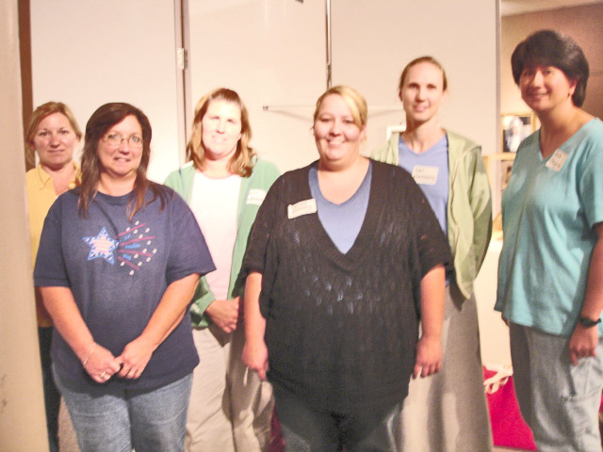

Art Presenters (including four new ones!). First row: Janet Cheek, Trina Richey. Second row: Cindy Jennett, Melissa Anderson, Elke Narkiewicz, Kath Sturgeon.

Buchanan Center for the Arts
Lila Blum

The sudden passing of Michael DiFuccia, director of Buchanan Center, has left us very sad. Michael was a good friend of AAUW and the Art Presenter Program, having spoken to our group at meetings we’ve held at the Center and supporting Art Presenter by preparing grant applications for Regrant Funds from the Illinois Arts Council that support our program. A memorial fund at Buchanan Center has been established in his name. Contributions will be used to remodel the classroom.

Buchanan Center will move ahead, as Michael would have wished, and hold the Taste of the Arts fundraiser on November 10 at 6:30 p.m. This year the Taste will take place at the Center and will feature a selection of wines from “The Wine Sellers” in Macomb and an array of interesting foods as well as art and wine sales, door prizes, and a silent auction. Your support is appreciated for a successful fundraiser, particularly in a year when arts funding in the state of Illinois is threatened by severe cuts. Tickets prices are $35. Call Lila (734-7553) or Jan (734-5529) for reservations or call the center at 734-3033.
Facts About the Illinois
Education Crisis
A+ Illinois
People across Illinois want to improve educational opportunities for all children. They are troubled by both the achievement gap and the spending gap between wealthy and poor school districts. They understand that the costs of inadequate education funding are high. Class sizes are growing; teachers are being laid off; schoolhouses are crumbling and overcrowded; sports, music, and art are being cut — and worst of all — students are struggling to learn.
It is Illinois' over-reliance on local property taxes to fund education that creates the enormous disparities in funding between local school districts. The current system also hurts our communities, with escalating property taxes driving businesses away and pushing housing costs out of reach. In addition, State revenues are not keeping up with the cost of existing services that children and families need.
Illinois consistently receives one of the worst grades in school funding equity from Education Week. In 2006 Illinois earned a D+; its ranking of C+ last year followed two years of receiving F grades.
Many schools across Illinois in city, suburban, and rural districts, are being forced to make tough decisions that compromise the quality of education they provide their students, increasing class sizes, laying off teachers, cutting important programs such as teacher training, and relying on outdated textbooks and equipment.
A shortage of high quality teachers exacerbates the situation. An insufficient number of specialized teachers, inability of high poverty districts to attract and retain teachers, job burnout, and lack of teacher training and mentoring are factors that create instability in classrooms.
On the most recent "nation's report card," Illinois had one of the nation's largest learning achievement gaps between students in poverty and wealthier students and has made no significant progress in closing these gaps in recent years.

Approximately 40 percent of Illinois' two million public schoolchildren are low income (approximately 825,000 students). One in three children who enter school are not ready when they start kindergarten. Yet, 40 percent of at-risk preschoolers cannot enroll in early childhood and school readiness programs because of a lack of program funding. One in four of Illinois' public schools failed to meet the annual requirements of the federal No Child Left Behind act.
The federal No Child Left Behind initiative requires annual achievement improvements among poor, minority and disabled students, with penalties for
school districts that don't improve. However, the way education is funded in Illinois does not support that effort. Instead, the Illinois education
funding system favors schools with the wealthiest tax base, leaving behind those with the largest concentrations of poor, minority, and/or disabled
students. Almost one in five of Illinois’ 881 school districts are facing serious financial difficulties, landing on the Financial Watch and Early Warning
Lists.
Research has found that fiscally efficient, high performing schools in Illinois spend $6,405 per student per year. Illinois' current foundation
level falls over $1,000 short of what is needed to get the job done. In Illinois, on average, local property taxpayers fund about 56 percent of school expenses, while the state pays only around 36 percent. This lags far behind the U.S. national average of states funding about 50 percent of the cost to educate a student.
About 40 percent of the state's 881 school districts operate with deficit budgets, spending more than revenues received. This results from many
factors, and occurs in fiscally responsible districts. For example, property tax caps, property tax appeals, and rapid population growth can quickly and negatively affect a school district's fiscal health. A huge investment gap exists between property-wealthy and property-poor communities. Per-child funding of education varies widely, from $23,000 to less than $5,000 per student per year, the result of an Illinois school funding mix of local, state and federal money that is over-reliant on local property taxes. The latest available data show that 46 school districts with about 45,000
students spent less than $6,000 per student, while 18 districts with over 48,000 students were able to spend over $14,000 per student.
Equalized Assessed Value per pupil varies from a low of $11,079 to a high of $1,852,142. Because of the over-reliance on the property tax to pay for
schools, low property wealth areas often pay much higher rates than areas with higher property wealth, and still generate less local funding for their schools. For example, a district with high EAV supports a per-pupil expenditure of over $18,000 with an operating tax rate of 1.395, while the low-EAV district with an operating tax rate of 5.725 (third highest in the state) brings in less than 10 percent of its $8,545 operating expense per
pupil.
Local property taxpayers pay local education taxes ranging from $6.67 per $100 of assessed value to $ .94 per $100 of assessed value — meaning a
taxpayer in one district pays seven times the tax rate but students receive less than two-thirds of the amount generated by the lower rate. (The
district with the $6.67 operating tax rate is able to spend only $8,405 per pupil while the district with the $ .94 rate spends $13,405 per pupil.)
AAUW-IL State News
Nancy K. Daugherty
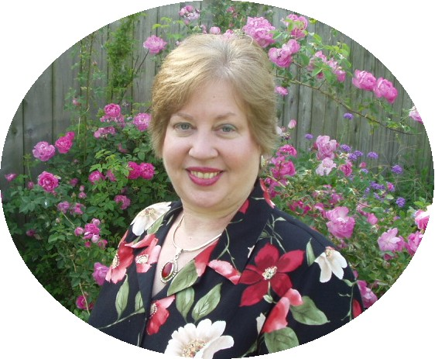

One bylaws change at the AAUW Convention was that AAUW is no longer affiliated with IFUW, and this needs to be amended in your branch bylaws. Since this was voted on at the Convention, it is a mandatory change, not requiring a branch vote. Of course, you need to inform your membership of the change. Your amended bylaws should be sent to the state bylaws chair, Cheryl Anderson, but not to the AAUW Bylaws Committee chair. Cheryl can be e-mailed at cma1480us@yahoo.com.
Contact information for state board members and branch officers is in the State Directory, which goes to branch Presidents. It should also be shared with branch officers as needed. This information is for AAUW purposes only. I would like to suggest that copies of the State Board’s contact information pages be provided to each board member for future reference, and for them to be sure to know, who their counterpart is should they have questions or concerns during the year. New Directories will be distributed at the Fall Conferences.
Donations to One Shared World (made payable to AAUW-IL, Inc.) should be sent to the following address:
Rachel Campbell
1198 Blackhawk Drive
Elgin, Illinois 60120

Per Jan Huttner, director of international relations, it is very important that this procedure be followed. When donations are sent either to the Association or directly to a project included in the Global Giving section of www.aauw.org, we're typically not informed at the state level. When you send the check to us, we will record the amount and ensure that your check reaches the destination you specify.
More details about One Shared World will be presented at the Fall Conferences.
As funds are donated to the Education Foundation, I would like to encourage branches to consider designating their funds to a specific fund to be more meaningful rather than just the general fund. In Illinois we are trying to complete the Joann Horowitz Research and Project Grant and the Mary Ellen Smyth American Fellowship.
Donations can also be designated to the Eleanor Roosevelt Fund, which supports the research projects. Donations to the Leadership and Training Institute support programming in AAUW.
Upcoming fall dates you don’t want to miss:

October 27: District 1, 2, & 3 Fall Conference
Richland Community College, Decatur
November: American Indian Heritage Month
November 1: Nominations due for Illinois State
Board positions
November 7: Election Day
November 28: Happy 126th Birthday to AAUW!

Branch Dates to Remember

¡Adelante! Book Group: October 11, 7 p.m., 502 College Manor, Monmouth
Branch Meeting: October 15, 7 p.m., Monmouth College Library, Len G. Everett Gallery
Monmouth Swans: October 29, 7 p.m., 207 S. 8th Street, Monmouth
Taste of the Arts Fundraiser: November 10, 6:30 p.m., Buchanan Center

Mission Statement: AAUW advances equity for women and girls through advocacy, education and research.

Vision Statement: AAUW will be a powerful advocate and visible leader in equity and education through research, philanthropy, and measurable change in critical areas impacting the lives of women and girls.

Association website: www.aauw.org
AAUW-Illinois website: www.aauw-il.org
Monmouth Branch website: http://department.monm.edu/aauw/
Initiative Editor: Amy Zesbaugh, zestib@hotmail.com

